# Crime Record management system

## 

## PROBLEM STATEMENT

A database management system , to maintain records of criminals and the crimes committed by them along with victim ,FIR , criminal details.

A petitioner can lodge many FIRs but they should not be of the same crime . He will have to provide details about his name , contact , address , gender and age while filing an FIR.

Many FIRs can be filed against one accused or one victim , but for different crimes.

Multiple victims or accused can not have the same FIR. Accused and victim details may or may not be known at the time of lodging a complaint.

FIR should include lodging date , time and place and also the incident date , time and place.

Victim’s details include name , age , gender, contact and address.

Accused details include name , UIN , gender m age , contact , address , status , alias , Identification.

One officer is assigned a case.

One officer can handle many cases.

## IDENTIFYING ENTITIES AND ATTRIBUTES

1. Petitioner { **Name** , Address , **Contact** , Age**,**Gender }
2. Officer {**O.Id** , OName , Rank }
3. Case {**C.Id** , Status , Description}
4. Accused { Name , **A_id,**Ad_no , Gender , Age , Contact , Address , Status , Alias , Identification}
5. FIR { **FIR.ID** , L_Date ,L_Time ,L_Place,i_Date,i_Time,i_Place }
6. Victim {**V_id** , Name, Age , Gender ,Contact , Address}

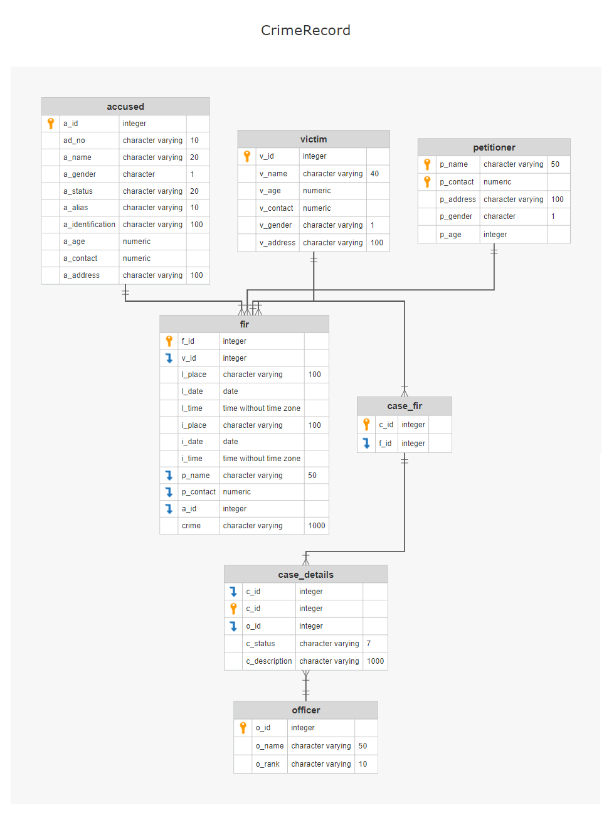

## 

## DATA

Accused :

|  |  |  |
| --- | --- | --- |
| Name | Gender | Ad_no |
| Andy Reyes | M | 7557576415 |
| Lester Higgins | M | 0945598818 |
| Bradford Gomez | M | 6400149025 |
| Micheal Jennings | M | 5270320077 |
| Bert Mitchell | M | 9534401788 |
| Minato Ellis | M | 6273139826 |
| Roosevelt Morgan | M | 4054967129 |
| Donald Woods | M | 3995706435 |
| Bena Kim | F | 4064893837 |
| Italia Robin | F | 7625789093 |
| Shalom Cross | F | 1916729587 |
| Christie Fox | F | 2941229216 |
| Denice Ritchie | F | 0817674655 |
| Eber Fields | M | 8527292704 |
| Luther Bailey | M | 1841693034 |
| Crystal Elliott | F | 8134954762 |
| Shawna Welch | F | 1397127847 |

Places:

|  |
| --- |
| Grand Creek |
| Fort Gisattbra |
| Northern Sma |
| Glarayal |
| Santa Sher |
| Mawat |
| Mount Kinze |
| Royal Elk Port |

Officers:

|  |  |  |
| --- | --- | --- |
| Officer ID | Name | Rank |
| 100 | Vixen Ray |  |
| 101 | Evan Mant |  |
| 102 | Ori Cruise |  |
| 103 | Croy Felt |  |
| 104 | Leon Grim |  |
| 105 | Elnora Lopez |  |
| 106 | Jameson S |  |
| 107 | Akira Wader |  |
| 108 | Akella |  |

Victims :

|  |  |  |
| --- | --- | --- |
| Name | Contact | Gender |
| Layla Rin | 5751028504 | F |
| Tianna Diam | 5733303487 | F |
| Alberta Cris | 6520589994 | F |
| Angela Fen | 4904031515 | F |
| Robin Sert | 5611403194 | M |
| Alexander Dunn | 1049040106 | M |
| Robin Horton | 1030850352 | M |
| Andrew Sutton | 4024852249 | M |
| Tracy Dawson | 1381308517 | M |
| Derrick Ramsey | 3701197982 | M |
| Andre Henry | 3801197982 | M |
| Edna Cross | 5611887694 | F |
| April Robinson | 8704121515 | F |
| Amy Lopez | 4434674315 | F |
| Nora Park | 4911511532 | F |
| Shawn Mcgee | 5644140124 | M |

## SQL QUERIES

Sequence

### OFFICER

#### DDL

CREATE TABLE public.officer

(

o_id integer NOT NULL DEFAULT nextval('officer_id'::regclass),

o_name character varying(50) COLLATE pg_catalog."default",

o_rank character varying(10) COLLATE pg_catalog."default",

CONSTRAINT officer_pkey PRIMARY KEY (o_id)

)

#### DML

Insert into officer(o_name,o_rank) values

('Vixen Ray','DGP'),

('Evan Mant','DCP'),

('Ori Cruise','DGP'),

('Croy Felt','DCP'),

('Leon Grim','ASP'),

('Elnora Lopez','ASP'),

('Jameson S','ASP'),

('Akira Wader','DCP'),

('Akella','DCP');

CREATE SEQUENCE public.officer_id

INCREMENT 1

START 100

MINVALUE 100

MAXVALUE 300

CACHE 1;

### ACCUSED

#### DDL

CREATE TABLE public.accused

(

a_id integer NOT NULL DEFAULT nextval('accused_id'::regclass),

ad_no character varying(10) COLLATE pg_catalog."default",

a_name character varying(20) COLLATE pg_catalog."default",

a_gender character(1) COLLATE pg_catalog."default",

a_status varchar(20),

a_alias character varying(10) COLLATE pg_catalog."default",

a_identification character varying(100) COLLATE pg_catalog."default",

a_age numeric(2,0),

a_contact numeric(10,0),

a_address character varying(100) COLLATE pg_catalog."default",

CONSTRAINT accused_pkey PRIMARY KEY (a_id),

CONSTRAINT accused_ad_no_check CHECK (ad_no::text ~ '^[0-9]*$'::text),

CONSTRAINT accused_a_gender_check CHECK (a_gender = ANY (ARRAY['M'::bpchar, 'F'::bpchar, 'm'::bpchar, 'f'::bpchar])),

CONSTRAINT accused_a_status_check CHECK (a_status::text = ANY (ARRAY['Bailed'::character varying, 'Released'::character varying, 'Arrested'::character varying, 'Escaped'::character varying]::text[])))

#### DML

INSERT INTO public.accused(ad_no, a_name, a_gender, a_alias, a_status, a_identification, a_age,a_contact,a_address)VALUES

('7557576415', 'Andy Reyes', 'M', 'Andy', 'Arrested', 'Mole on the chin', '34',NULL,'12th Street ,Popy Gram'),

('0945598818', 'Lester Higgins', 'M', 'Lester', 'Arrested', 'Scar on the face', '31',1113456789,'87th Lane, Pacific'),

('6400149025', 'Bradford Gomez', 'M', 'Brad', 'Bailed', 'Mole on stomach', '24',3567780983,'109th Lane,Mawat'),

('5270320077', 'Micheal Jennings', 'M', 'Jenning', 'Dead', 'Blue eyes', '26',4443986771,NULL),

('9534401788', 'Bert Mitchell', 'M', 'Bert', 'Bailed', 'Bald', '45',NULL,NULL),

('6273139826', 'Minato Ellis', 'M', 'Ellis', 'Arrested', 'Ear missing', '63',6661029102,'Christian Ro , 12th lane ,Grand Creek'),

('4054967129', 'Roosevelt Morgan', 'M', 'Morgan', 'Arrested', 'Lip ring', '19',9912029901,'34th Street , Comer ,Glarayal'),

('3995706435', 'Donald Woods', 'M', 'Donald', 'Dead', 'Orange face', '28',NULL,NULL),

('4064893837', 'Bena Kim', 'F', 'Kim', 'Arrested', '6 fingers on left hand', '39',9901234323,NULL),

('3995712935', 'Frost Bing', 'F', 'Frost', 'Dead', 'Eye patch', '32',7878909872,NULL),

('3078706435', 'Damon Bill', 'M', 'Billerin', 'Bailed', 'Curly hair', '25',NULL,'Mason Billen , 38th street , Portiol');

CREATE SEQUENCE public.accused_id

INCREMENT 1

START 10000

MINVALUE 10000

MAXVALUE 30000

CACHE 1;

### VICTIM

#### DDL

CREATE TABLE public.victim

(

v_id integer NOT NULL DEFAULT nextval('victim_id'::regclass),

v_name character varying(40) COLLATE pg_catalog."default",

v_age numeric(2,0),

v_contact numeric(10,0),

v_gender character varying(1) COLLATE pg_catalog."default",

v_address character varying(100) COLLATE pg_catalog."default",

CONSTRAINT victim_pkey PRIMARY KEY (v_id),

CONSTRAINT victim_v_gender_check CHECK (v_gender::text = ANY (ARRAY['M'::character varying, 'F'::character varying, 'm'::character varying, 'f'::character varying]::text[]))

)

#### 

#### DML

INSERT INTO public.victim(

v_name, v_age, v_contact, v_gender, v_address)VALUES

('Layla Rin', '35','5751028504', 'F', '23rd street , RIN ,Grand Creek'),

('Tianna Diam', '23','5733303487', 'F', '12th street , MADY , Glarayal'),

('Alberta Cris', '25','6520589994', 'F', '8th street , Santa Sher'),

('Angela Fen', '41','4904031515', 'F', '9th street Mount Kinze'),

('Robin Sert', '23','5611403194', 'M', '234,Royal Elk Port'),

('Alexander Dunn', '26','1049040106', 'M', 'Northern Sma'),

('Robin Horton', '46','1030850352', 'M', '16,Mount Kinze'),

('Andrew Sutton', '48','4024852249', 'M', 'Fort Gisattbra'),

('Tracy Dawson', '51','1381308517', 'M', '216,Royal Elk Port'),

('Derrick Ramsey', '14','3701197982', 'M', '180,Mount Kinze'),

('Andre Henry', '17','3801197982', 'M', 'Fort Gisattbra'),

('Edna Cross', '39','5611887694', 'F', '38th street , Santa Sher'),

('April Robinson', '35','8704121515', 'F', 'Mawat');

CREATE SEQUENCE public.victim_id

INCREMENT 1

START 1000

MINVALUE 1000

MAXVALUE 3000

CACHE 1;

### PETITIONER

#### DDL

CREATE TABLE public.petitioner

(

p_name character varying(50) COLLATE pg_catalog."default",

p_contact numeric(10,0),

p_address character varying(100) COLLATE pg_catalog."default",

p_gender character(1) COLLATE pg_catalog."default",

p_age integer,

CONSTRAINT petitioner_pkey PRIMARY KEY (p_name ,p_contact),

CONSTRAINT petitioner_p_gender_check CHECK (p_gender = ANY (ARRAY['M'::bpchar, 'F'::bpchar, 'm'::bpchar, 'f'::bpchar]))

)

#### DML

INSERT INTO public.petitioner(

p_name, p_contact, p_address, p_gender, p_age)VALUES

('Lon Prince', 8903284489, '90th Lane , Lon , Fort Gisattbra', 'M', 45),

('Oswaldo Swann', 8896521456, '28th Lane ,House 6 Glarayal', 'M', 23),

('Theo Shackelford', 1145236789, 'Mayden street ,Santa Sher', 'M', 39),

('Benton Ratliff', 2563478965, 'Fort 23 , Royal Elk Port', 'M', 46),

('Rico Birch', 1204563104, 'Campsite 12 , Grand Creek', 'M', 29),

('Cassandra Miller', 4120365897, 'Wayden street , Mount Kinze', 'F', 75),

('Laura Black', 5639870125, 'Fort 62 ,Royal Elk Port', 'F', 36),

('Sheryl Ortega', 1470325896, 'Daymon street , House 23 ,Glarayal', 'F', 57),

('Genevieve Becker', 2340156398, 'Forben mount Moss street , Northern Sma', 'F', 36),

('Christy Gonzalez', 1048763025, 'Redrick Chase , Mawat', 'F', 41);

### FIR

#### DDL

CREATE TABLE fir

(

f_id SERIAL PRIMARY KEY,

v_id int , l_place varchar(100),

l_date date DEFAULT current_date,

l_time time default current_time ,

i_place varchar(100),

i_date date, i_time time,

p_name varchar(50),

p_contact numeric(10),

a_id int , crime varchar(1000),

constraint fir_fk1 FOREIGN KEY(a_id) references accused(a_id),

constraint fir_fk2 FOREIGN KEY(p_name,p_contact) references petitioner(p_name,p_contact),

constraint fir_fk3 FOREIGN KEY(v_id) references victim(v_id)

);

#### DML

INSERT INTO public.fir(v_id, l_place, l_date, l_time, i_place, i_date, i_time, p_name, p_contact, a_id,crime) VALUES

(1000, 'Glarayal','2014-09-13', '12:20', 'Glarayal','2014-09-12', '10:00', 'Lon Prince', 8903284489, 10000, 'Murder'),

(1001, 'Mawat','2015-07-11', '10:10', 'Mount Kinze','2015-07-11', '7:00', 'Oswaldo Swann', 8896521456, 10001, 'Theft:Shoplifting'),

(1002, 'Northern Sma', '2015-06-10', '06:45','Glarayal', '2015-06-09', '10:45', 'Benton Ratliff', 2563478965, 10002, 'Theft:Stole from Locker'),

(1003, 'Royal Elk Port', '2016-08-24', '09:45','Royal Elk Port', '2016-08-23', '6:30', 'Cassandra Miller', 4120365897, 10004, 'Rape'),

(1004, 'Santa Sher', '2012-05-16', '6:28','Santa Sher', '2012-05-15', '11:30', 'Laura Black', 5639870125, 10003, 'Kidnapping'),

(1005, 'Northern Sma', '2014-02-22', '02:06','Mawat', '2014-02-21', '12:15', 'Sheryl Ortega', 1470325896, 10005, 'Arson'),

(1006, 'Mount Kinze', '2016-04-13', '16:50','Fort Gisattbra', '2016-04-12', '16:20', 'Genevieve Becker', 2340156398, 10006, 'Attack:Acid attack'),

(1007, 'Grand Creek', '2017-12-09', '12:30','Grand Creek', '2017-12-08', '22:35', 'Christy Gonzalez', 1048763025, 10007, 'Vandalism:Keyed a car'),

(1008, 'Santa Sher', '2019-01-06', '05:45','Fort Gisattbra', '2019-01-06', '03:45', 'Rico Birch', 1204563104, 10008, 'Assault on Husband'),

(1009, 'Royal Elk Port', '2015-12-26', '10:20','Mawat', '2015-12-25', '09:50', 'Benton Ratliff', 2563478965, 10007, 'Rape'),

(1010, 'Grand Creek', '2013-11-14', '07:35','Grand Creek', '2013-11-13', '07:36', 'Theo Shackelford', 1145236789, 10010, 'Assault on Wife'),

(1011, 'Mount Kinze', '2016-10-28', '05:15','Mount Kinze', '2016-10-27', '06:25', 'Oswaldo Swann', 8896521456, 10009, 'Rape'),

(1012, 'Fort Gisattbra', '2013-06-25', '06:33','Mawat', '2013-06-24', '10:10', 'Cassandra Miller', 4120365897, 10008, 'Murder');

### CASE_FIR

#### DDL

CREATE TABLE case_fir(

c_id integer DEFAULT nextval('case_id'::regclass) PRIMARY KEY ,

f_id integer,

constraint case_fir_fk FOREIGN KEY(f_id) references fir(f_id)

);

#### DML

INSERT INTO case_fir(f_id) VALUES

(1),

(2),

(3),

(4),

(5),

(6),

(7),

(8),

(9),

(10),

(11),

(12),

(13);

CREATE SEQUENCE public.case_id

INCREMENT 1

START 10000

MINVALUE 10000

MAXVALUE 30000

CACHE 1;

### CASE_DETAILS

#### DDL

create table case_details(

c_id int PRIMARY KEY,

o_id int ,

c_status varchar(7) CHECK(c_status in ('OPEN','CLOSED')),

c_description varchar(1000),

CONSTRAINT cd_fk1 FOREIGN KEY(c_id) references case_fir(c_id),

constraint cd_fk2 FOREIGN KEY(o_id) references officer(o_id)

);

#### DML

insert into case_details VALUES

(10000,101,'CLOSED','A lady from Glarayal was shot dead "by accident" . Accused claims he intender to shoot someone else , was charged of Murder and sentenced to jail for 12 years'),

(10001,102,'CLOSED','A pharmacy Store in Mount Kinze was shoplifted.Medicines worth at least 30000 dollars had been robbed.The accused was Sentenced to 5 years of imprisonment'),

(10002,102,'OPEN','A Locker at the Central Library had been robbed by a group of 3 thieves. Only one of them was caught.'),

(10003,103,'CLOSED','THe victim was brutally raped . The accused was sentenced to death.'),

(10004,108,'CLOSED','The victim was walking to her everyday Gym , and was abducted and killed for money.The accused is sentenced to death.'),

(10005,104,'CLOSED','A house property along with the papers had been set on fire due to some inter-family matters , by a close cousin.The accused is sentenced to life-time imprisonment.'),

(10006,102,'OPEN','The accused threw Hydrochloric Acid on the victims face outside the Stroi College . Reason of Crime under investigation. Accused under arrest and in in for questioning'),

(10007,105,'CLOSED','The famous Pontiac bandit under arrest again for keying a BMW outside Grand Villa.Accused under arrest and under lockdown for 8 days with an additional payment of 4000 dollars.'),

(10008,103,'CLOSED','Wife had gone missing after attacking husband with a knife. Victim;s condition is stable. She was found 5 days later and sentenced to 7 years of jail.'),

(10009,106,'OPEN','A teenage girl was allegedly raped by her uncle when nobody was home, accused sentenced to death.'),

(10010,103,'CLOSED','Husband after assaulting wife for not making him Chicken wings , is under arrest and will have to spend 10 days in jail along with a necessary payment of 10000 dollars for assaulting wife multiple times.'),

(10011,107,'OPEN','The victim was gang-raped by 4 men .Three escaped , case still under investigation.The accused found is under investigation.'),

(10012,108,'OPEN','A lady from Mawat killed her brother with an axe. Criminal under police custody. Reason for murder is not known yet. Court summoning to start from July .');

## RETRIEVAL QUERIES

1. Display the names of those victims , the status of the case , and the officer who filed the case , where the incident took place in Mawat

select v_name,o_name,c_status from

(

(

(

(fir join victim on fir.v_id = victim.v_id)

JOIN case_fir on fir.f_id = case_fir.f_id

)

JOIN case_details on case_fir.c_id = case_details.c_id

) JOIN officer on officer.o_id = case_details.o_id

)

where i_place = 'Mawat'

Output

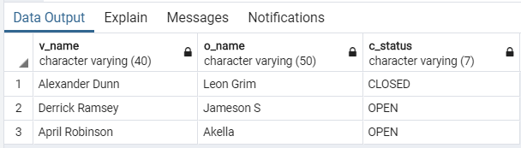

1. Display the victim names,address and the petitioner name of the crimes which took place in May of any year where the petitioner is a Female.

SELECT v_name, p_name

From

(

SELECT * FROM victim NATURAL JOIN fir

WHERE EXTRACT(MONTH FROM i_date)=5

)

AS FOO NATURAL JOIN petitioner

Where p_gender='F';

Output

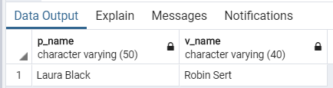

1. Display the crime details with criminal status , case status and description of the crime of those crimes which took place after 15th of any month and year.

select a_status,c_status,c_description from

(

(

(

fir JOIN accused AC on AC.a_id = fir.a_id

)

JOIN case_fir CF on CF.f_id = fir.f_id

)

JOIN case_details CD on CD.c_id = CF.c_id

)

where (EXTRACT(DAY FROM fir.i_date) >15)

Output

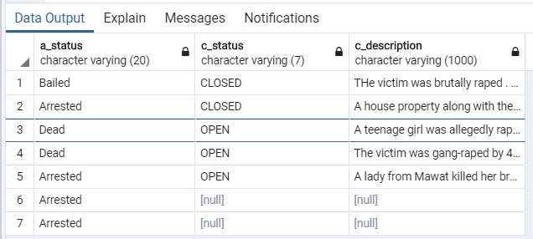

1. Display the criminal details and associated crimes , with the victim name for a criminal named Roosevelt Morgan.

select a_name,a_contact,ad_no,c_description,v_name,crime from

(

((

(fir JOIN accused AC on AC.a_id =fir.a_id )

JOIN case_fir CF on CF.f_id = fir.f_id

)

JOIN case_details CD on CD.c_id = CF.c_id

)JOIN victim on fir.v_id = victim.v_id

)

where AC.a_name = 'Roosevelt Morgan'

Output

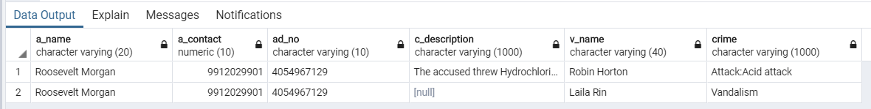

1. Count and details of criminals who are dead/bailed who were in an incident whose victim is dead
2. Count of status of criminals where the case closed/open

SELECT a_status, Count(a_status)

FROM(

SELECT DISTINCT(a_id), a_status, a_name

FROM (SELECT * FROM (case_details NATURAL JOIN case_fir NATURAL JOIN fir) WHERE c_status='OPEN') AS func NATURAL JOIN accused) AS foo

Group BY(a_status);

Output:

